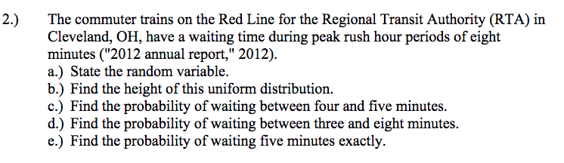

- Waiting time
- Height = 1/8
- = $\frac{5}{8}-\frac{4}{8}$
= 1/8
- 1- $\frac{3}{8}$
= 5/8
- =5/8
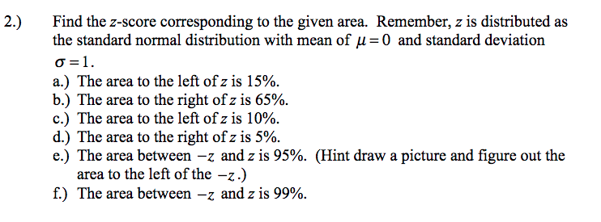

- P = 0.15
From the normal distribution table, the corresponding z-value is:
Z = -1.0364
- Right of p = 0.65
= 1-0.65
= 0.35
From the normal distribution table:
Z= -0.3853
- Area to the left of z is 10%
From normal distribution
Z = 1.2816
- Area right to z is 5%
From z-value
Z = 1.6449
- Between -z and z at 95%
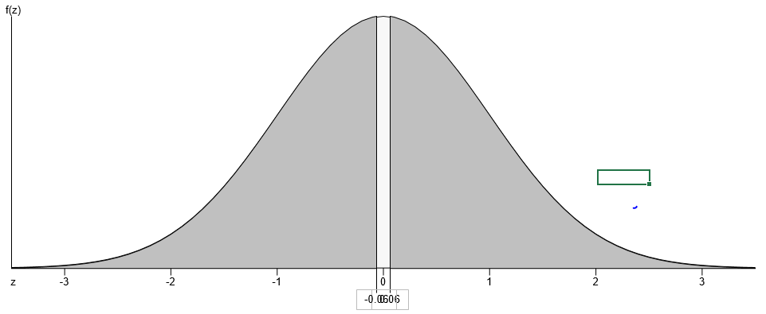
Z- value lies between -0.06 and 0.06
- Area between -z and z at 99%
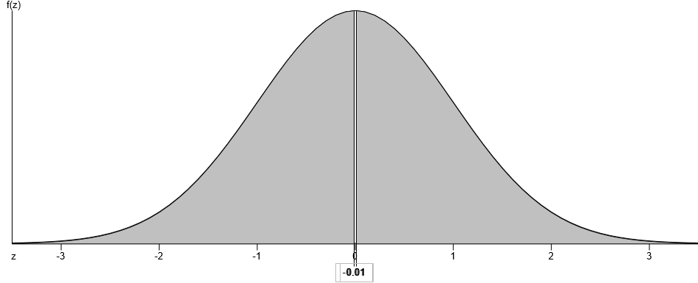
The area lies between -0.01 and 0.01
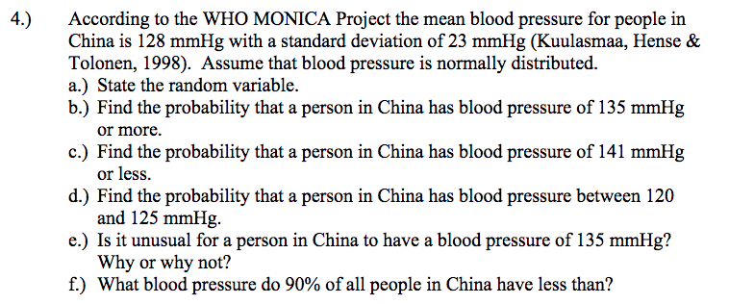

- Random variable is blood pressure
- Mean = 128 mmHg
Standard deviation = 23 mmHg
Pressure of 135 mmHg
= $\frac{135-128}{23}$
z-value = 0.30
p(x> 135) = 1 – p( <135)
= 1 – 0.6179
= 0.3821
- Less than 141 mmHg
= $\frac{141-128}{23}$
z-value =0.57
p-value = 0.7157
- Between 120 and 125 mmHg
= $\frac{120-128}{23}$
= -0.35
p-value = 0.3632
= $\frac{125-128}{23}$
= -0.13
p-value = 0.4483
probability between = 0.4483 – 0.3632
= 0.0851
- Is it ussual for china people to have blood pressure of 135 mmHg
It is ussual since the p-value (0.6179) is greater than 0.5
- Pressure of 90% of china people
From the normal distribution table the z-score = 1.28
1.28= $\frac{x -128}{23}$
23(1.28) = x -128
x = 157.44

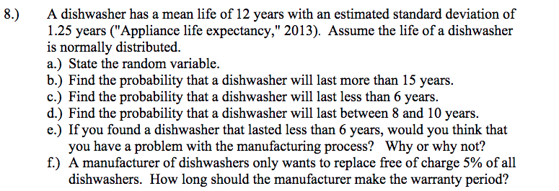
Solution
- Random variable is life of a dishwasher
- Will last more than 15 years
z-value = $\frac{15 -12}{1.25}$
= 2.4
P(x≥15) = 1 – p(x<15)
= 1 – 0.9918
= 0.0082
- Will last less than 6 years
= $\frac{6-12}{1.25}$
z-value = -4.8
p-value = 0.0002
- Probability will last between 8 and 10 years

z-value = $\frac{8 -12}{1.25}$
= -3.2
p-value = 0.0007
z-value = $\frac{10 -12}{1.25}$
= -1.6
p-value = 0.0548
probability between 8 and 10 = p(x<12) – p(x<8)
= 0.0548 – 0.0007
= 0.0541
- There is a problem with the manufacturing process since the p-value is too small.
- Replace 5% of all dishwashers for free
From the normal distribution table z-score = -1.65
-1.65= $\frac{x-12}{1.25}$
-1.65(1.25) + 12=x
x = 9.94
the warranty period should be 9 years.

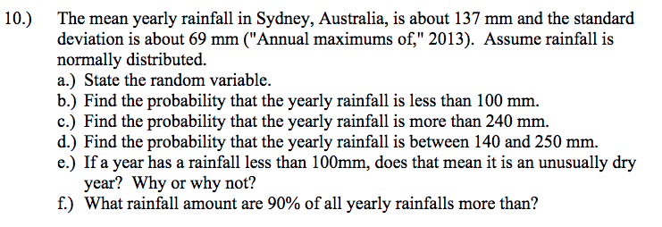
Solution
- Random variable is rainfall
- Probability that it is less than 100 mm
= $\frac{100-137}{69}$
= -0.54
p-value =0.2946
- Probability that yearly rainfall is more than 240 mm.
= $\frac{240-137}{69}$
z-score = 1.49
p(x>240) = 1 – p(x< 240)
= 1 – 0.9319
= 0.0681
- Probability yearly rainfall is between 140 and 250 mm.
z-score = $\frac{140-137}{69}$
= 0.04
p-value = 0.5160
for x = 250
z-score = $\frac{250-137}{69}$
= 1.64
p-value = 0.9495
probability = 0.9495 – 0.5160
= 0.4335
- Rainfall of 100mm means it is unusually dr year since p-value is less than 0.5 (50%)
- Rainfall amount of 90% more than all yearly rainfall.
z-score = -1.29
1.28(69) + 137 = x
x = 225.32

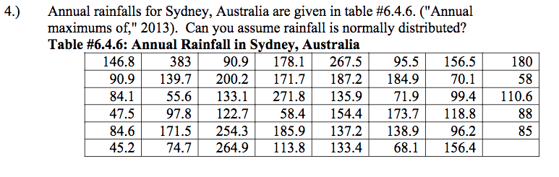
Solution

The data can assumed to be normally distributed since mean and median are at the same point.

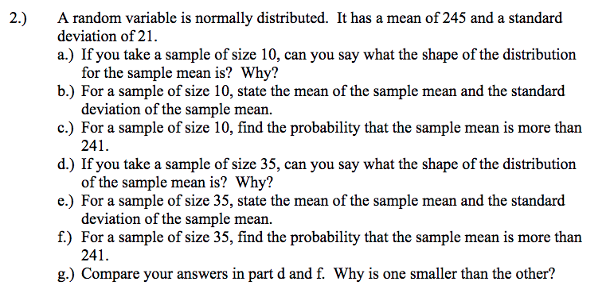

Solution
- The shape of the distribtion is normally distribted
- Sample mean = 245
Standard deviation = $\frac{21}{\sqrt{10}}$
= 6.64

- Probability that sample mean is more than 241
Z-score = $\frac{241-245}{6.64}$
= -0.60
p-value = 0.2743
p(x>241) = 1-0.2743
= 0.7257
- I would say that the distribtion of the sample is normal since the sample size is large, greater than 30.
- Mean = 245
Standard deviation = $\frac{21}{\sqrt{35}}$
= 3.55
- Probability that sample mean is more than 241
Z-score = $\frac{241-245}{3.55}$
= -1.13
p-value = 0.1292
p(x>241) = 1-0.1292
= 0.8708
- The answer in C is smaller than the answer in F because part C has a smaller sample size (10) than part F (35). The larger the sample size the lower the standard deviation and the lower the z-score.

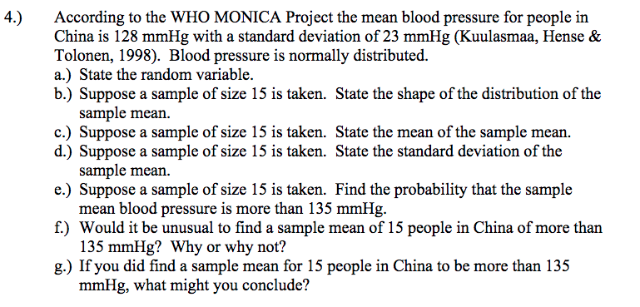
Solution
- Random variable is blood pressure
- The shape of a sample of 15 is bell-shaped hence approximately normally distributed.
- Mean = 128 mmHg
- Standard deviation = $\frac{23}{\sqrt{15}}$
= 5.9386
- Probability that mean blood pressure is more than 135 mmHg
z-score = $\frac{135-128}{5.9386}$
= 1.18
p-value = 0.8810
P(x≥135) = 1 – p(x<135)
= 1- 0.8810
= 0.1190
- It is unusual to find a sample of 15 with mean pressure greater than 135 mmHg since p-value is less than 0.5 (50%)
- I would conclude that most China people are at risk of suffering from health related issues.

s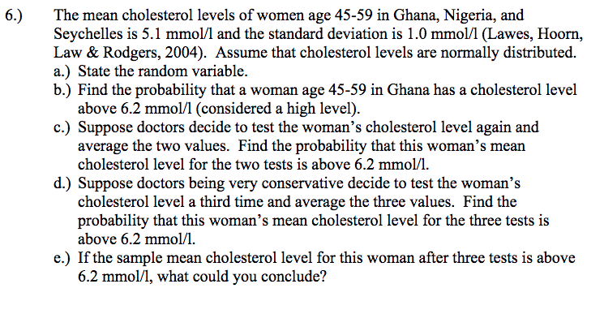
solution
- Cholesterol levels in women
- Cholestrol levels above 6.2
Z-score =$\frac{6.2-5.1}{1}$
= 1.1
p-value = 0.8643
p(x> 6.2) = 1 – 0.8643
= 0.1357
- Z-score =$\frac{6.2-5.1}{\frac{1}{\sqrt{2}}}$
= 1.56
p-value = 0.9406
p(x> 6.2) = 1 – 0.9406
= 0.0594
- Z-score =$\frac{6.2-5.1}{\frac{1}{\sqrt{3}}}$
= 1.91
p-value = 0.9719
p(x> 6.2) = 1 – 0.9719
= 0.0281
- I would conclude that wonen have more cholestereo levels.

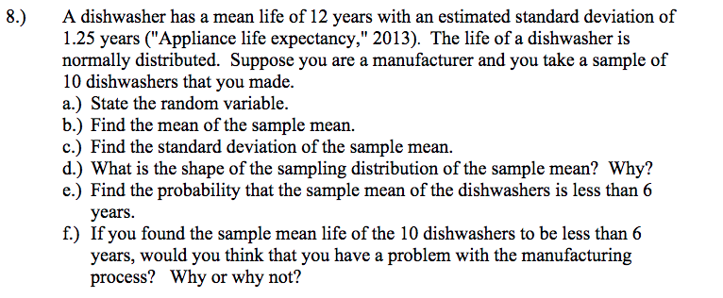

Solution
- Mean life of a dishwasher
- Sample mean = 12 years
- Sample standard deviation = $\frac{1.25}{\sqrt{10}}$
= 0.3953
- The distribution is bell shaped since it is approximately normally distributed.
- Probability that sample mean of dishwashers is less than 6 years
z-score = $\frac{6-12}{0.3953}$
= -15.17
p-value < 0.0001
- Yes, since the mean life is too short.

